Caesar Cipher Activity Name _______________________
The following message was encrypted using the classic +13 key. Use your cipher wheel to decode the text.
AB BAR JVYY OR NOYR GB QRPBQR BHE ZRFFNTR.

Encode the following plaintext to cipher text using the key of +5.
MEET AT THE BRIDGE. COME ALONE.

The following message was encoded using an unknown key, can you decrypt?
X HDATBCAN HLTPG X PB JE ID CD VDDS.

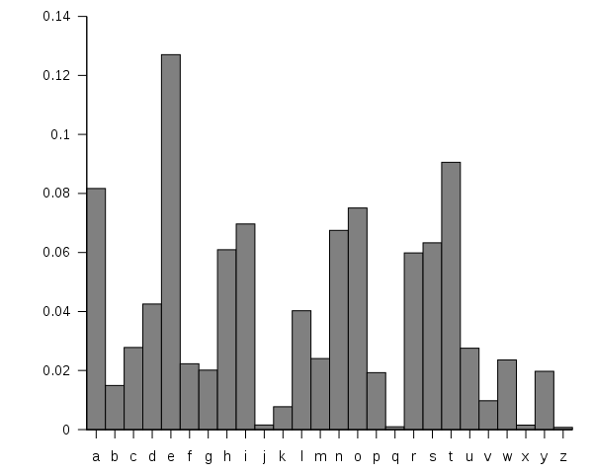
That last problem was too easy. Here is another one that was encrypted with an unknown key but the spaces and punctuation have been removed. Drat.
I know the frequency of letters in the English language is this:
JCRRCPDPCOSCLAWAYLZCYSQCDSJAJSC

Here is the frequency analysis on the phrase.
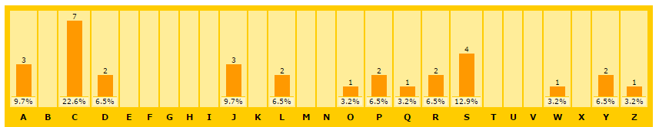
On the back, encode a message of your choice with a key of your choice. We will try to break these messages in a moment as a class.

