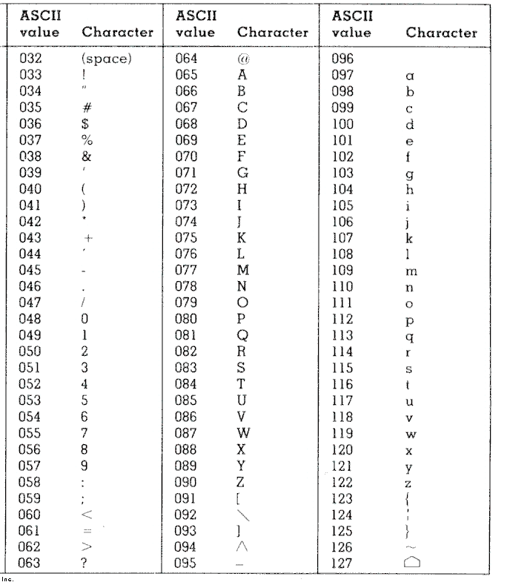
ASCII & Binary Conversion Name _______________________
Using the ASCII chart, convert the message “Hello world!” into numbers.

Convert the message 073 116 039 115 097 108 108 110 117 109 098 101 114 115 046 to text.

Convert a message of your choosing into ASCII.

Swap with another group and convert their ASCII back to text.

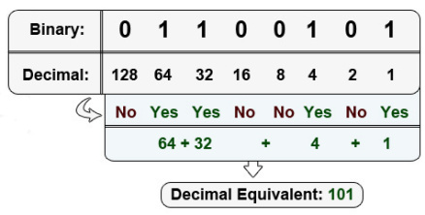

Decode the following message by converting the binary to decimal then finding the corresponding ASCII letter.

01000011 01101111 01101101 01110000
01110101 01110100 01100101 01110010
00100000 01010011 01100011 01101001
01100101 01101110 01100011 01100101
00100000 01010010 01110101 01101100
01100101 01110011 00100001

____ ____ ____ ____ ____ ____ ____ ____ ____ ____ ____ ____ ____ ____ ____
____ ____ ____ ____ ____

