Morse Code Activity Name _______________________

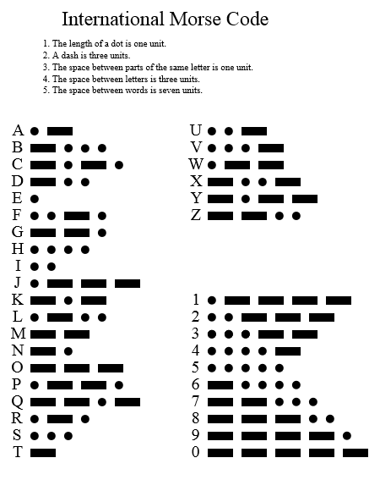
Students should encode a message in Morse Code.

Swap with another person’s message and decode.

Listen to a sample of Morse Code and translate it to written form.

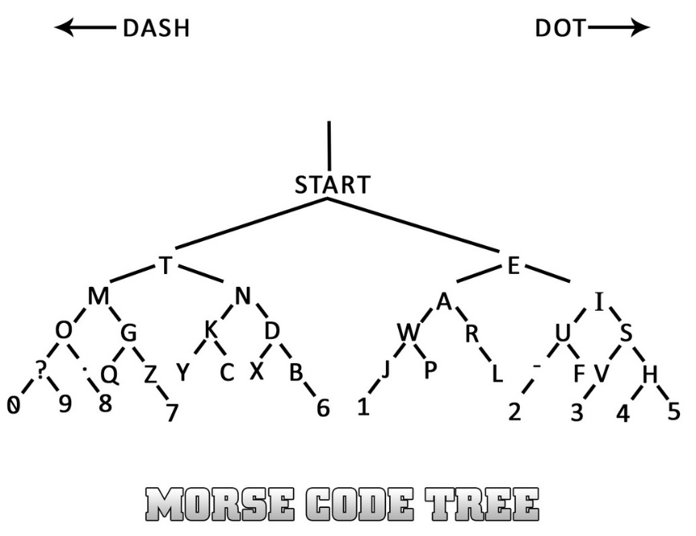
Rather than writing down the dots and dashes, try to follow the Morse Code tree.

