Symbol Cipher
During the 16th century, a group plotted to overthrow Queen Elizabeth I as ruler of England and replace her with Mary Queen of Scots. There were political, religious, and social forces at work but ultimately, the plot was uncovered when the code Mary was using was uncovered.
This was the coding system used by Mary Queen of Scots and her collaborators.
Note that not every letter has a symbol, W, V, and J are absent.
There are also null letters, they have no meaning but are used to confuse a would-be reader of the text. These can be placed anywhere without affecting the text.
Finally, the Dowbleth character indicates two of the following letter rather than using the same character twice.
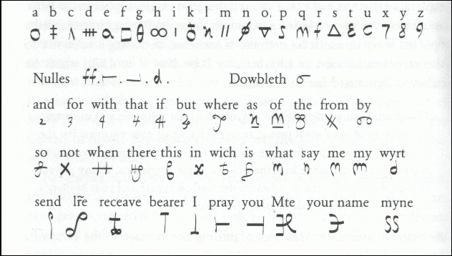
Encode the following sentence and check it with a classmate: you are not safe there

Encode a message of your choosing. Once encoded, swap with another person/group and have them decode your message while you decode their message.

To put a modern spin on Mary Queen of Scots’ cipher, we want to create our own symbol language using emojis.
A | B | C | D | E | F | G | H | I | J
K | L | M | N | O | P | Q | R | S | T
U | V | W | X | Y | Z | . | ? | ,

Create any additional words, nulls, rules, or shortcuts:

Encode a message:

As before, swap with another group and decode their message.

